**Mr. Visca’s: Calculus (Chpt 5.1)**

**Chpt 5 – Day 1: Estimating w Finite Sums**

***INTRO…”Here comes the Boom! (B)”***

The need to calculate instantaneous rates of change led the discoverers of calculus to an investigation of the slopes of tangent lines and, ultimately, to the derivative—to what we call *differential* calculus. But derivatives revealed only half the story. In addition to a calculation method (a “calculus”) to describe how functions change at any given instant, they needed a method to describe how those instantaneous changes could accumulate over an interval to produce the function. That is why they also investigated *areas under curves,* which ultimately led to the second main branch of calculus, called *integral* calculus.

Once Newton and Leibniz had the calculus for finding slopes of tangent lines and the calculus for finding areas under curves—two geometric operations that would seem to have nothing at all to do with each other—the challenge for them was to prove the connection that they knew intuitively had to be there. The discovery of this connection (called the Fundamental Theorem of Calculus) brought differential and integral calculus together to become the single most powerful insight mathematicians had ever acquired for understanding how the universe worked.

**5.1 Related Rates**

* Rectangular Approximation Methods (***____________***):
* LRAM - ___________ RAM
* RRAM - ___________ RAM
* MRAM - ___________ RAM

RAM is used to find the _____________________________________________

- Consider an object moving at a constant rate of 3 ft/sec.

Since (rate)(time) = distance: _________________

If we draw a graph of the velocity, the distance that the object travels is equal to the ***_______________________***.

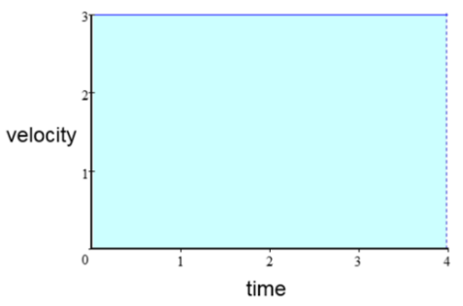

After 4 seconds, the object has gone 12 feet

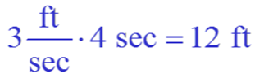

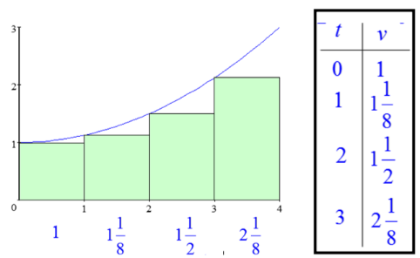BUT...what if the velocity is ***_____________________***, we might guess that the distance traveled is still equal to the area under the curve.

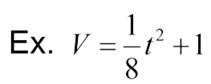

We could estimate the area under the curve by

drawing rectangles touching at their

***____________________________***

This is called the Left-hand Rectangular

Approximation Method ***_____________***

Approximate Area is: ________________________________

We could also use a Right-hand Rectangular Approximation Method _________________.

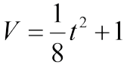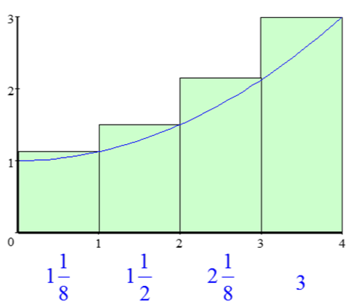

Approx Area: _______________________________

Another approach would be to use rectangles that touch at the midpoint. This is the Midpoint Rectangular Approximation Method ____________________.

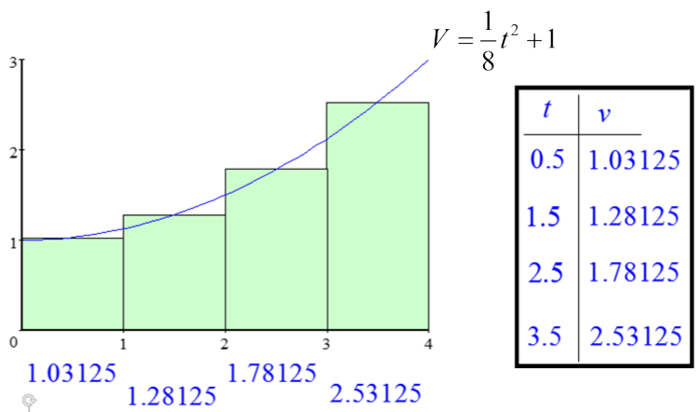

Approximate Area: _____________________

In this example there are four subintervals. As the number of subintervals ***___________________,***

so does the ***_____________________.***

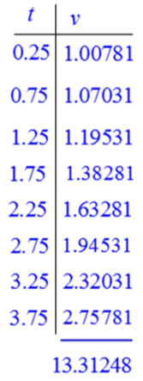

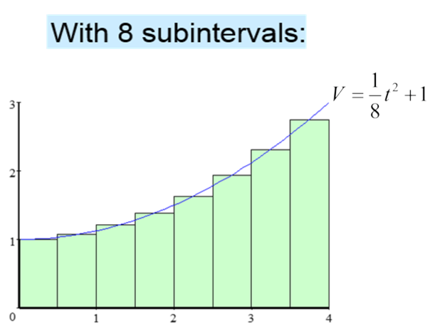

Approx Area:

Exact Area:

________________________

**Rectangular Approximation Methods**

* LRAM: ***__________________*** than true area
* RRAM: ***__________________*** than true area
* MRAM: ***__________________***to true area

More ___________________ = More ______________________

Notation: MRAM10 - means ______________________

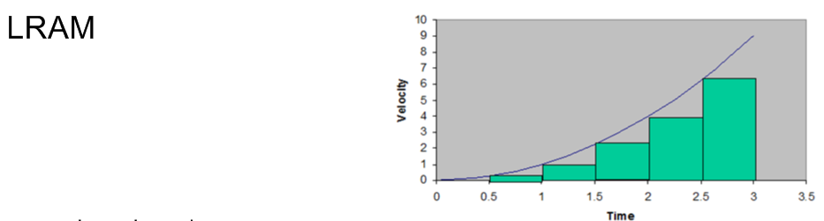Ex. Ex. A particle starts at x=0 and moves along the x-axis with velocity v(t)=t2 for time t >0. Where is the particle at t=3? (use 6 intervals)

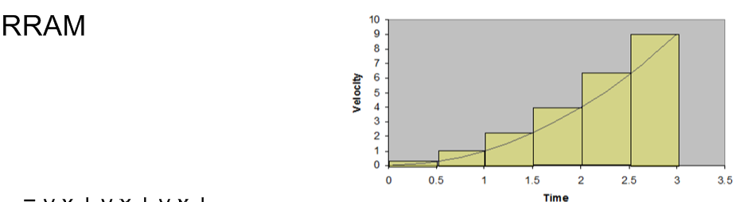

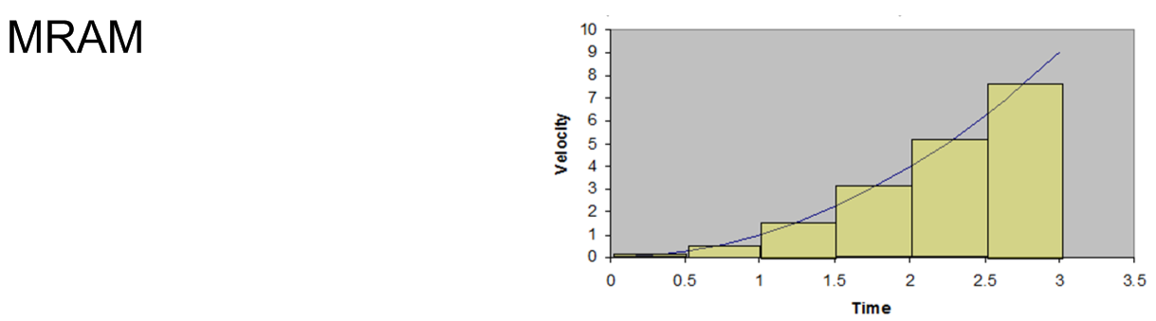

**HOMEWORK:**

Page 270-271 (1-6, 17)